Selenium Hybrid Framework
(Python, Selenium, PyTest, Page Object Model, HTML Reports)
Step 1: Create new Project & install required packages/plugins
- Selenium: Selenium libraries
- PyTest: Python UnitTest framework
- Pytest-html: PyTest HTML Reports
- Pytest-xdist: run tests parallel
- Openpyxl: MS Excel Support
- Allure-pytest: to generate allure reports
Step 2: Create Folder Structure
Project Name
|
PageObjects (Package)
|
testCases (Package)
|
Utilities (Package)
|
testData (Folder)
|
Configurations (Folder)
|
Logs (Folder)
|
Screenshots (Folder)
|
Reports (Folder)
|
Run.bat

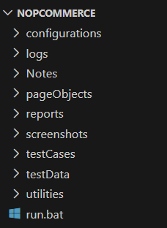

Step 3: Automating Login Test Case
3.1: Create LoginPage Object Class under “PageObjects”
3.2: Create LoginTest under “testCases”
3.3: Create conftest.py under “testCases”

Step 4: Capture screenshot on failures
4.1: Update Login Test with Screenshot under “testCases”

Step 5: Read common values from ini file.
5.1: Add “config.ini” file in “Configurations” folder
5.2: Create “readProperties.py” utility file under utilities package to read common data.
5.3: Replace hard coded values in Login test case.

Step 6: Adding logs to test cases.
6.1: Add customerLogger.py under utilities package.
6.2: Add logs to Login test case.

Step 7: Run tests on desired browser/ cross browser/ parallel
7.1: Update conftest.py with required Fixtures which will accept command line argument (browser).
7.2: Pass browser name as argument in command line

To run tests on desired browser
pytest -s -v testCases/test_login.py --browser chrome
pytest -s -v testCases/test_login.py --browser firefox

To run tests parallel
pytest -s -v -n=3 testCases/test_login.py --browser chrome
pytest -s -v -n=3 testCases/test_login.py –browser firefox

Step 8: Generate pytest HTML reports
8.1: Update conftest.py with pytest hooks.
8.2: To generate HTML report run below command:
pytest -s -v testCases/test_login.py --browser_name=chrome --html=reports\report.html --self-contained-html
Step 9: Automating Data Driven Test Case
9.1: Prepare test data in Excel sheet, place the excel file inside the TestData folder.
9.2: Create “ExcelUtils.py” utility class under utilities package.
9.3: Create LoginDataDrivenTest under testCases.
9.4: Run the test case.

Step 10: Adding new test cases
10.1: Add new customer.
10.2: Search customer by email.
10.3: Search customer by name.
Step 11: Grouping tests
11.1: Grouping markers (Add markers to every test method).
@pytest.mark.sanity
@pytest.mark.regression

11.2: Add marker entries in pytest.ini file.
@pytest.ini
------------
[pytest]
Markers =
Sanity
regression

11.3: Select groups at run time.
-m “sanity”
-m “regression”
-m “sanity and regression”
-m “sanity or regression”

Run Command:
pytest -s -v -m "sanity" --browser_name=chrome testCases/ --html=reports/report.html --self-contained-html

Step 12: Run tests in command prompt & run.bat file.
12.1: Create run.bat file

pytest -s -v -m “sanity” –html=./Reports/report.html testCases/ –-browser chrome

12.2: Open command prompt as Administrator and then run run.bat file.

Step 13: Pust the code to Git and Github repository.
1st Round
Initial steps (only one time)
- git init Create an Empty git repo (local repo)
- git remote add origin “<repo-link>”
Before doing the first commit for the first time, we need to execute below commands.
git config –global user.name “Mrunal”
git config –global user.email mrunalkukre29@gmail.com
- git status
- git add . add all the files in the indexing/staging area
- git commit -m “comment”
- git push -u origin master

2nd Round
Git pull pulls all the files from github to local

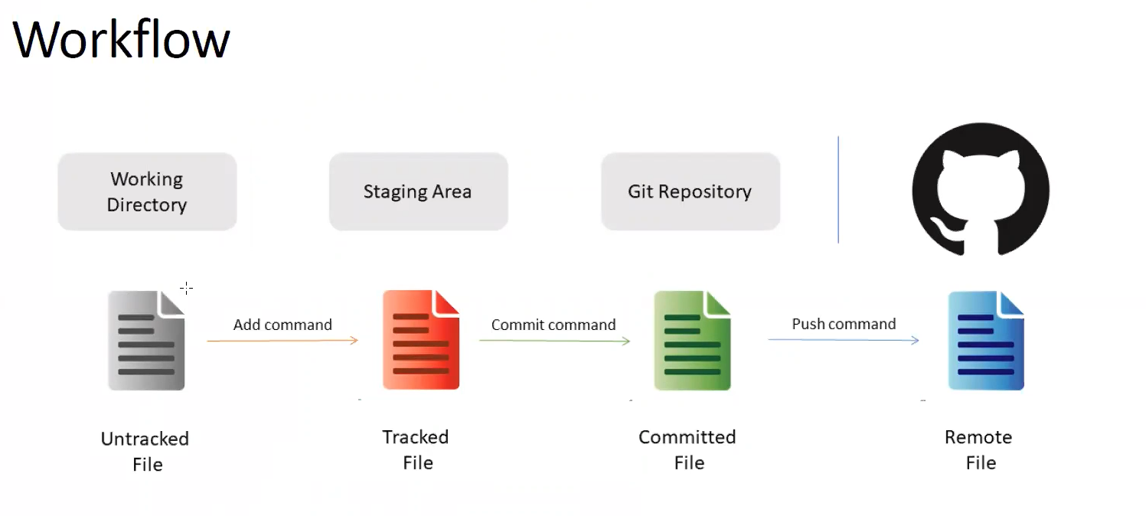
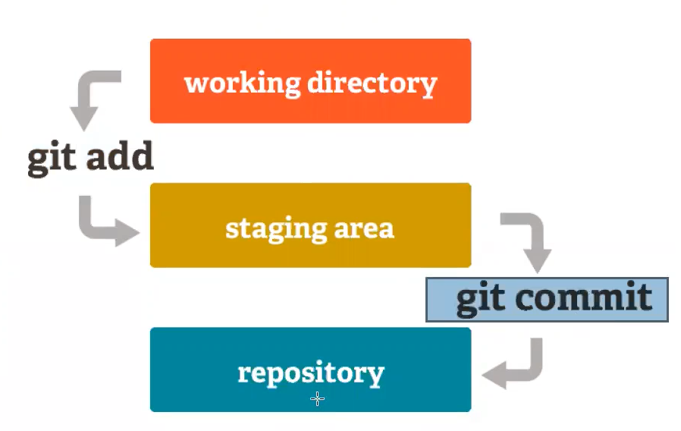
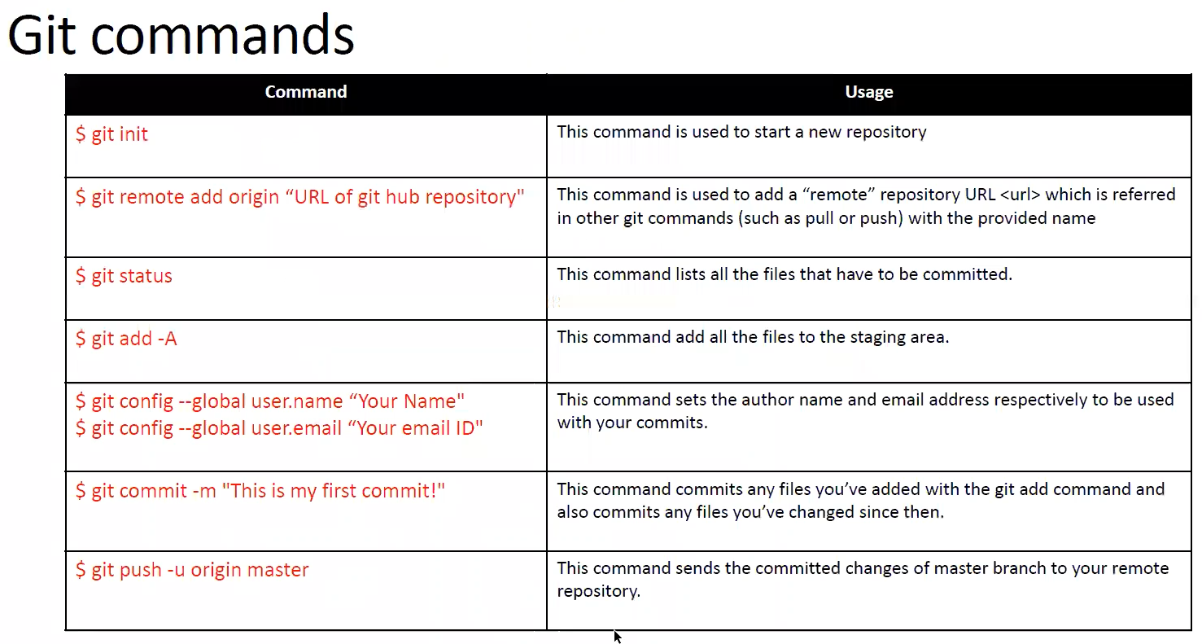

Step 14: Run tests using Jenkins.
- Download the Jenkins.war file from Jenkins and store it in a “Jenkins” folder in C drive.
- Open CMD for the same path and run Jenkins.war file.
java -jar jenkins.war --enable-future-java
- Once you run the file, open chrome with localhost:8080.
- Sign in to Jenkins using the initialAdmin password in C:\Users\Snehal\.jenkins\secrets folder.
- Configure Jenkins for your project (New item Project name github project url commands (run.bat) save build)

